**Module: R5: RV-fpga**

**Section:** Installations **Task:** Tools

**Task 1.2**

**RVfpga-ViDBo**

* **Testing:**
  + **RVfpga-ViDBo**
    1. For using this simulator in Ubuntu it is required to first install websockets library, which can be easily achieved by executing the following command in a terminal:

sudo apt-get install -y libwebsockets-dev

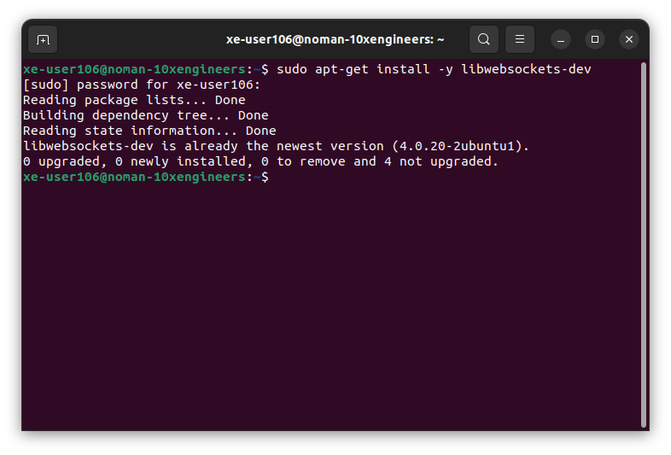

* + 1. Opened the specified folder of example program in VS Code:

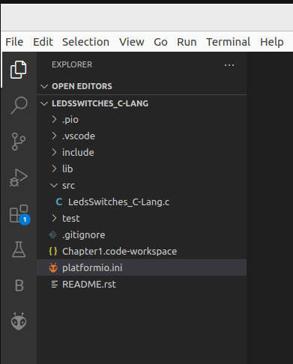

* + 1. PlatformIO will now open this program, LedsSwitches_C-Lang, that reads the switch values on the Nexys A7 board and writes their value onto the LEDs on the board. We can view the LedsSwitches_C-Lang program by expanding the src folder and double-clicking on LedsSwitches_C-Lang.c.

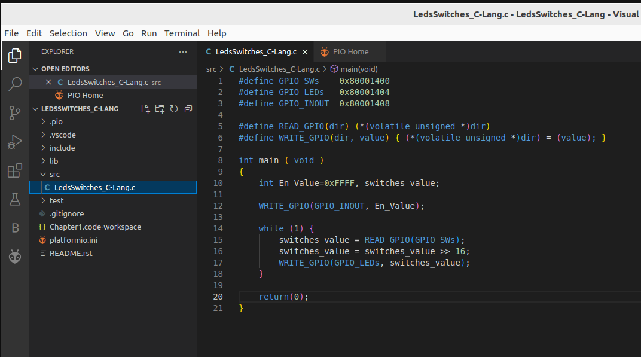

* + 1. Open file **platformio.ini**. Then, established the path to the provided RVfpga-ViDBo simulator binary by editing the following line (replaced [Path-To-RVfpga] with the appropriate path in my system and chose the binary that corresponds to my Ubuntu version):

board_debug.verilator.binary = /home/xe-user106/RVfpga/Simulators/verilatorSIM_ViDBo/OriginalBinaries/RVfpga-ViDBo_Ubuntu22

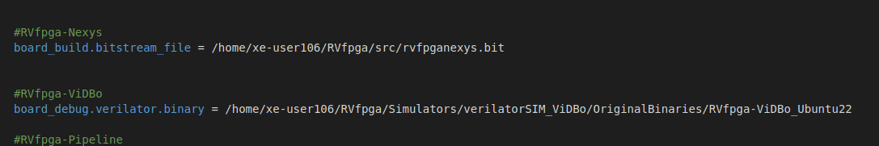

* + 1. Executed the RVfpga-ViDBo simulator from PlatformIO:
       - Click on the PlatformIO button on the left side.
       - Expand Project Tasks > env:swervolf_nexys > Platform and clicked on **RVfpga-ViDBo/Pipeline**.

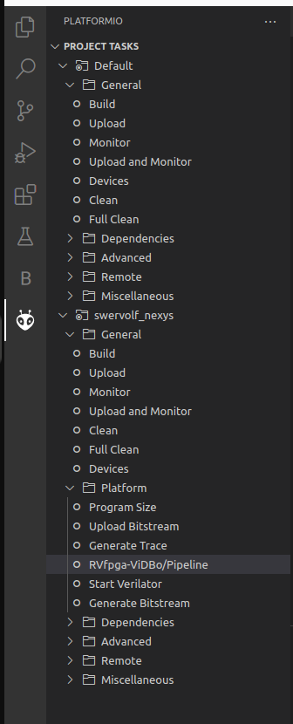

This first compiles the program and then launches the Verilator simulation of the RVfpga SoC running this program.

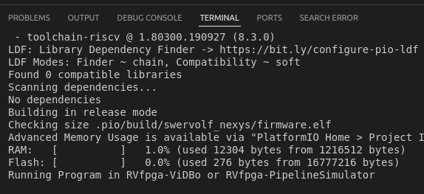

* + 1. Once the RVfpga-ViDBo is executing, I launched the python server simulating the Nexys A7 board.
    2. Open a terminal. Just go into the ***/RVfpga/Simulators/verilatorSIM_ViDBo*** directory.

Execute the python server by running the following command:

python3 -m http.server --directory NexysA7board/.

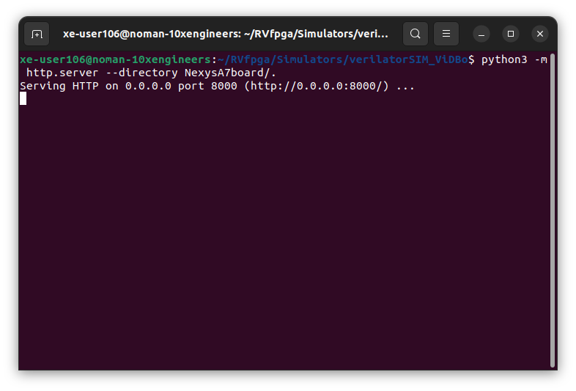

* + 1. Open a browser and connect to [**http://localhost:8000/nexys-a7.html**](http://localhost:8000/nexys-a7.html).

Click on Connect to the board and test the program.

